BEHAVIOUR ANALYSIS FOR MENTALLY AFFECTED PEOPLE
In this project student want to detect people’s mental behaviour by analysing there’s emotions and to implement this project we have used Facial Expression dataset and SVM machine learning algorithm. SVM is trained with facial expression dataset and then SVM trained model can be used to detect human mental behaviour. To implement this project we have designed following modules
- Webcam connection: using this module application will be connected to live webcam
- Load & Preprocess Dataset: using this module application read all dataset images from numpy array and then normalize and extract features from images.
- Train SVM Algorithm: Extracted features will be used to train SVM algorithm
- Capture Person: using this module we will capture person image and then detect face from that image
- Detect Emotion: This module will take detected face as input and then by using SVM algorithm will predict person mental behaviour as SAD, HAPPY, NEUTRAL, ANGRY etc.
SCREN SHOTS
To run project double click on ‘run.bat’ file to get below screen
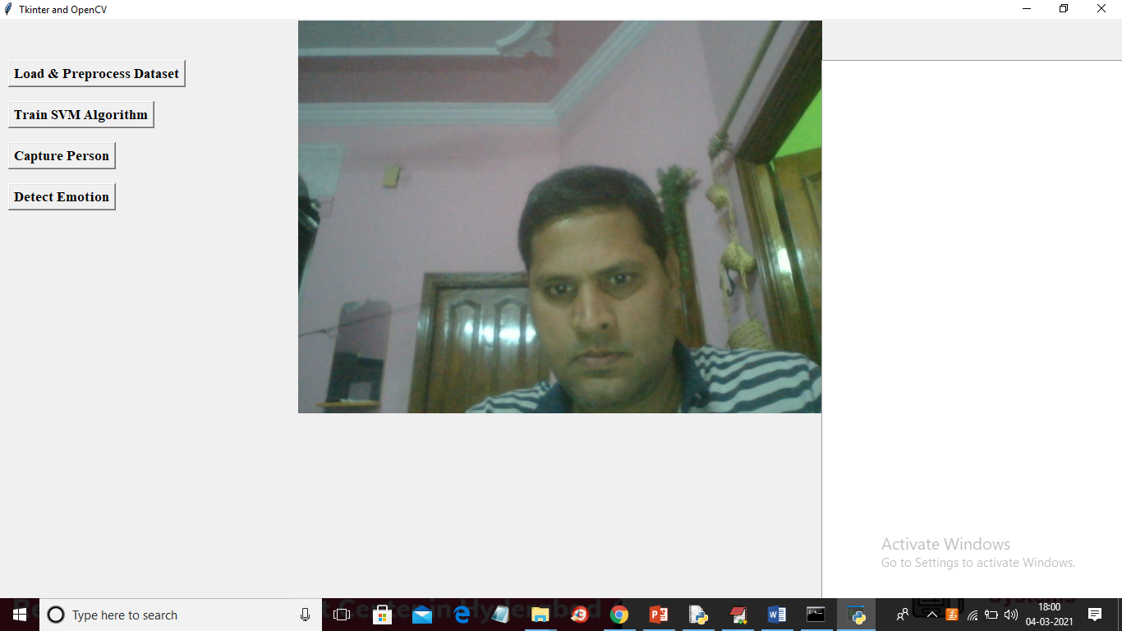
In above screen web cam started and now click on ‘Load & Preprocess Dataset’ button to read images and process them. This process may take 2 to 3 minutes of time
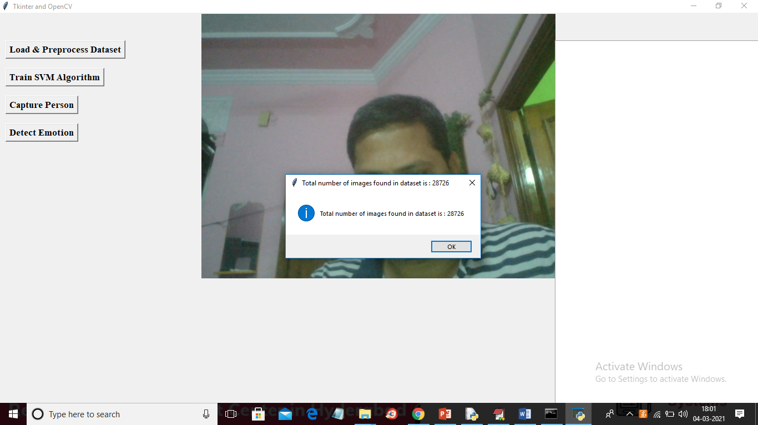
In above screen we can see application process 28726 images and now click on ‘Train SVM Algorithm’ button to train SVM with all those images
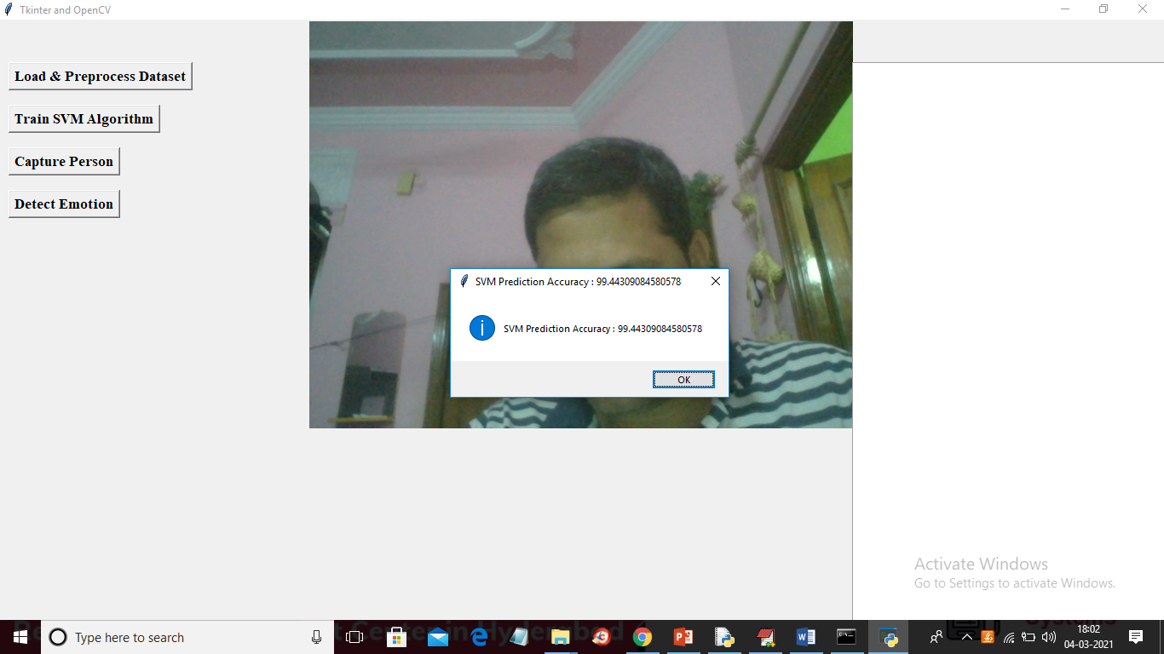
In above screen SVM model trained with prediction accuracy as 99%. Now make some expression and then click on ‘Capture Image’ button to get below screen
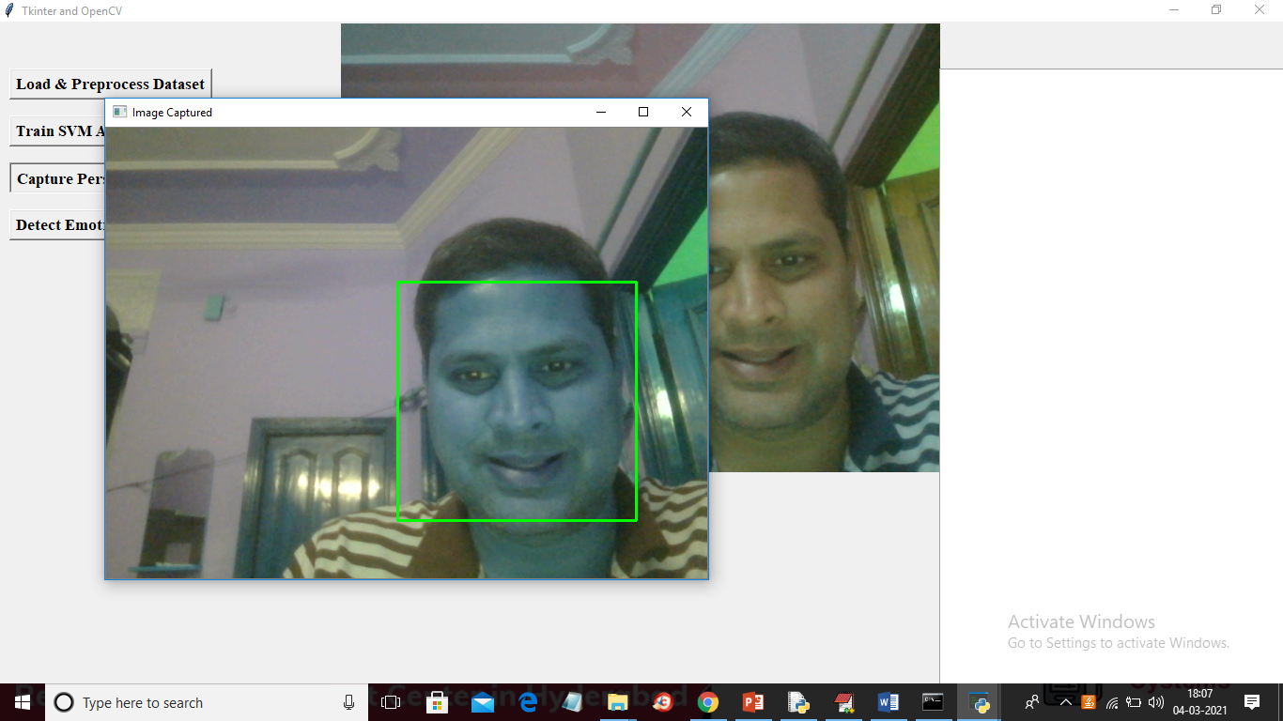
Below is the prediction result
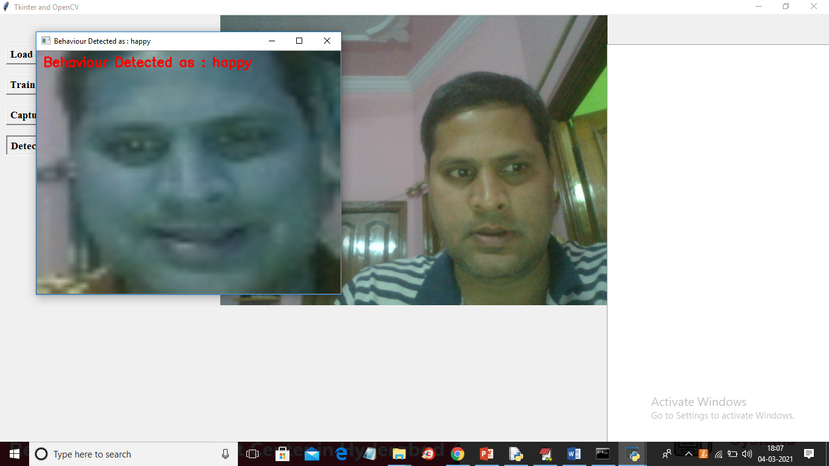
Below is next emotion
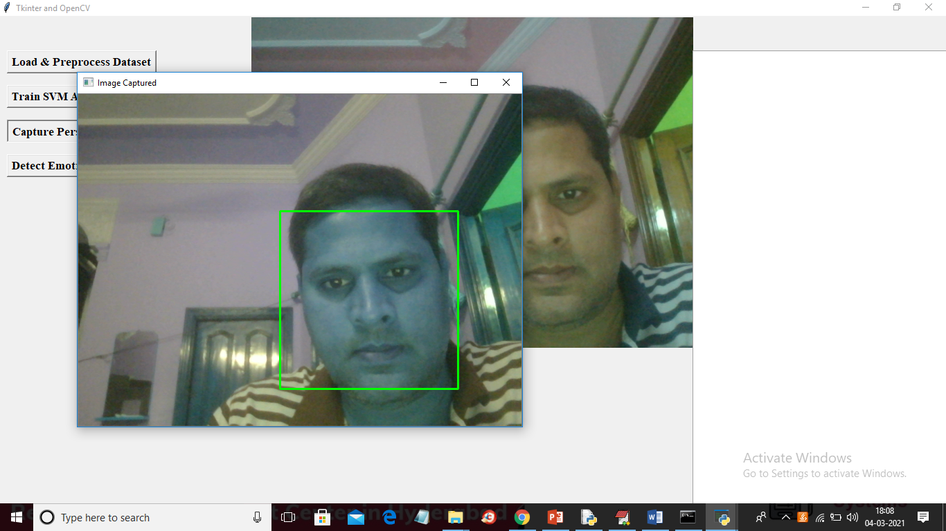
Below is the prediction result
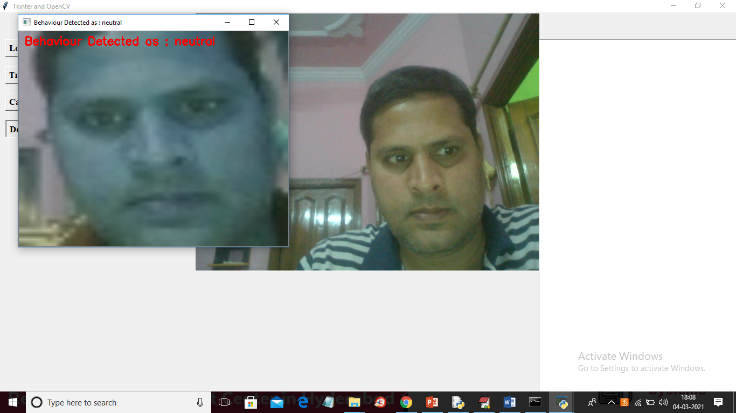

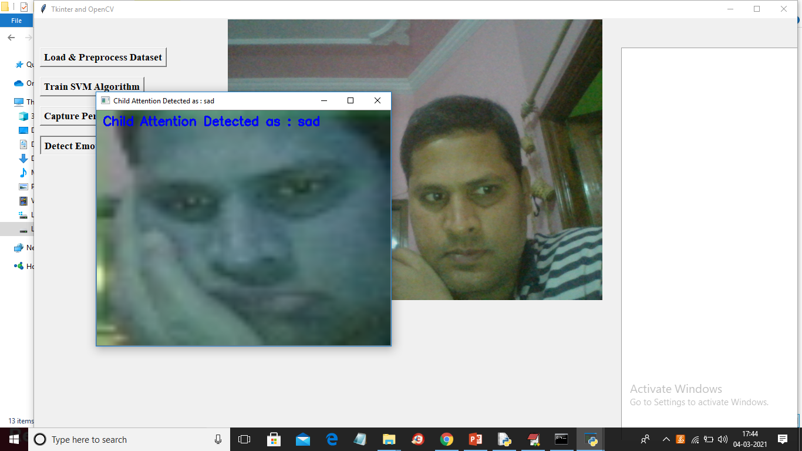
Note: we need to make proper expression to get correct result and you can try with below images also. To test from images click on ‘Detect Emotion From Images’ button and upload image
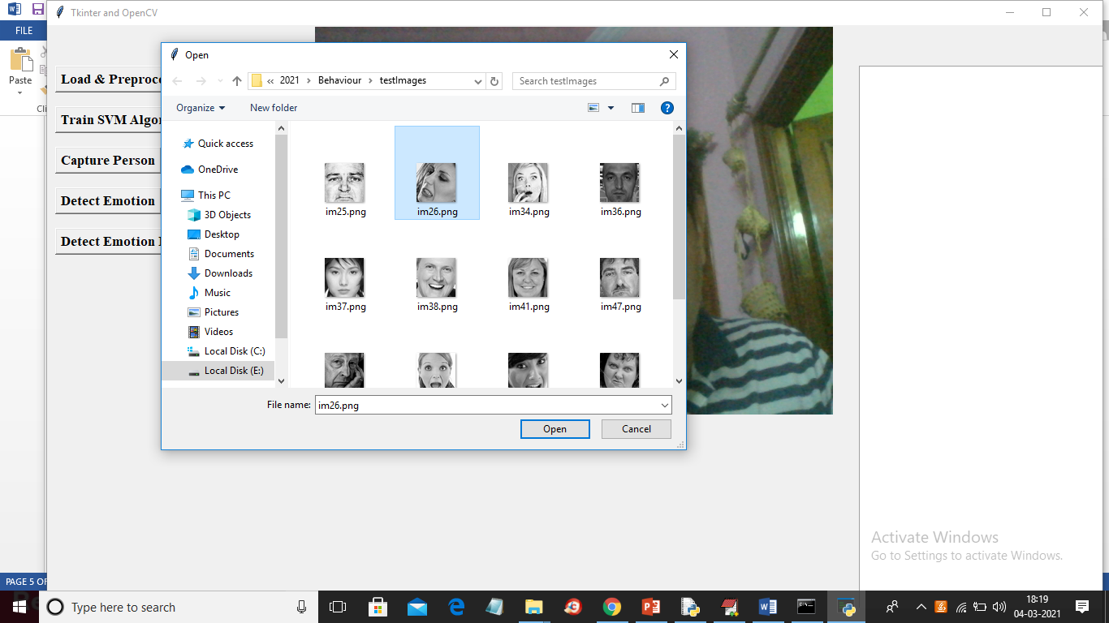
In above screen selecting and uploading im26.png file and below is the result
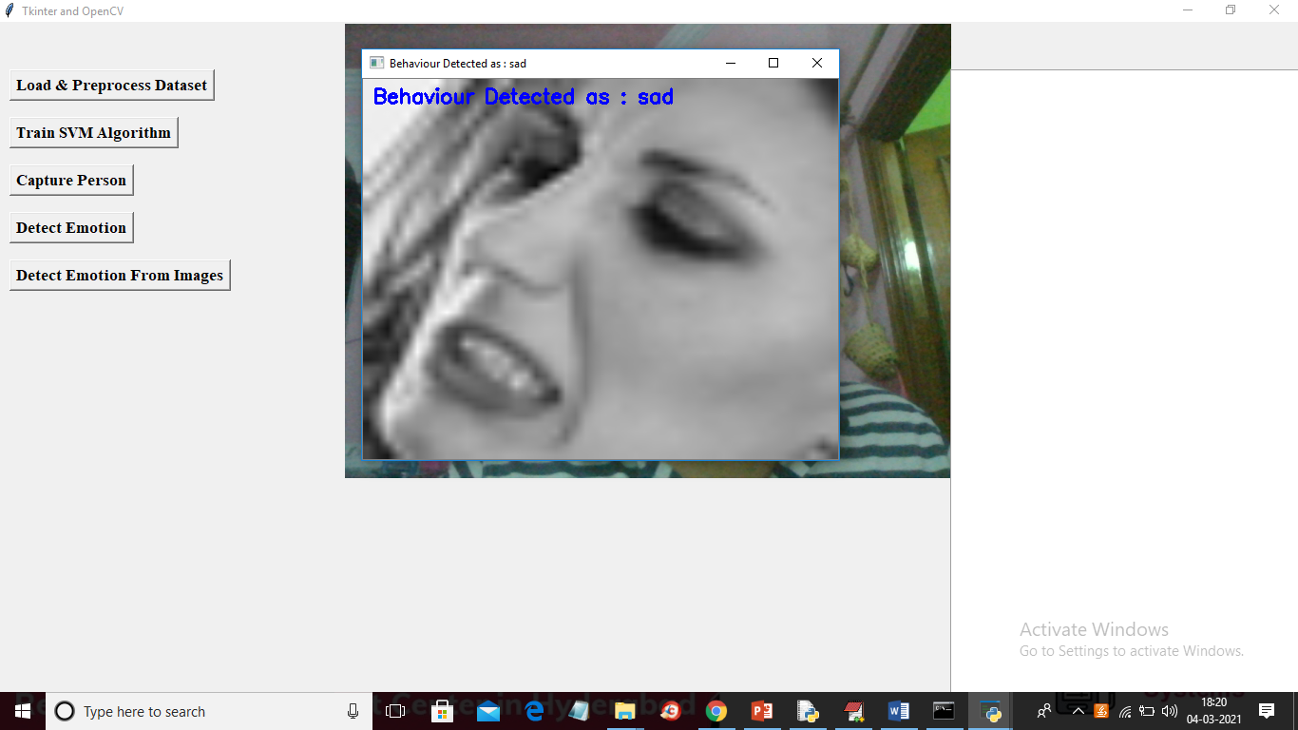
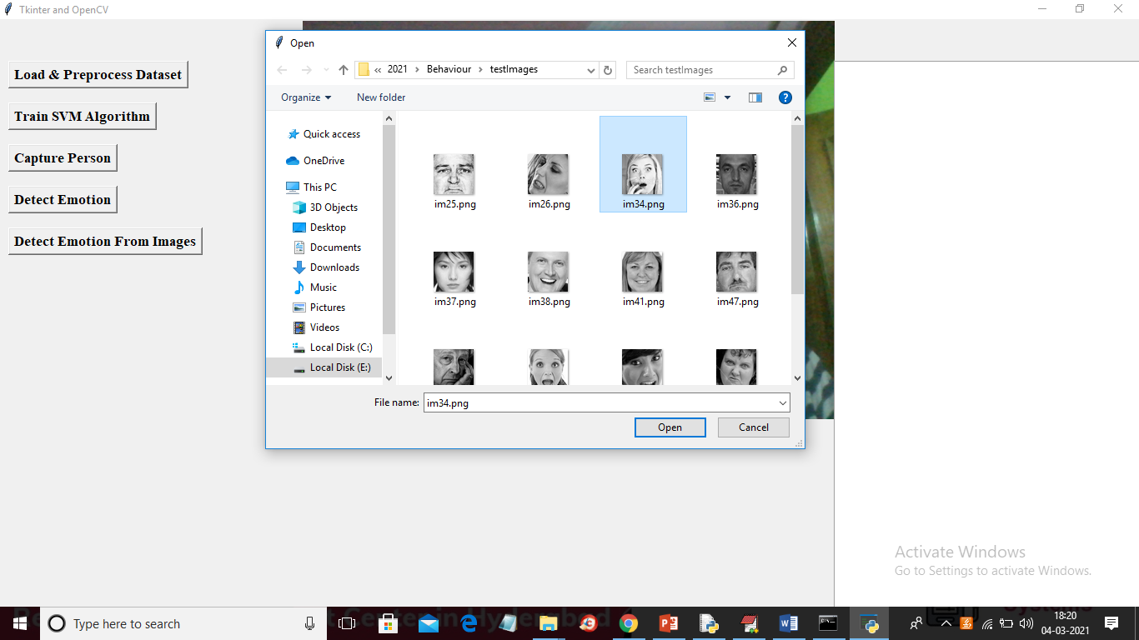
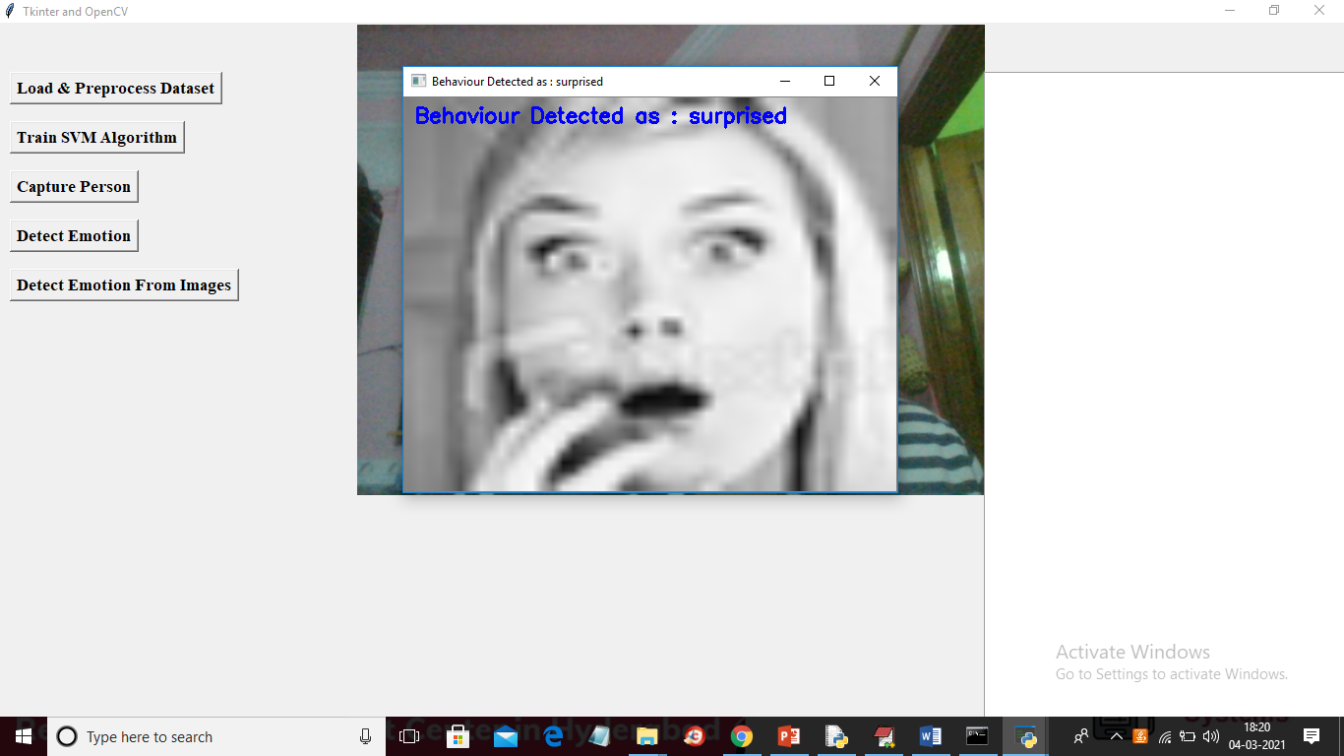
So in above screens application giving proper result so from webcam also we need to make exact expression to get proper result

